**Block 1 Practice 1**

|  |  |  |
| --- | --- | --- |
| Questions | Assessment  Standard | Subskill details |
| 1,2 | A1.1 | find equation of line parallel or perpendicular to given line |
| 3,4 | A1.1 | use |
| 5, 6, 7, 8 | EF1.3 | identify and sketch related functions |
| 9 | EF1.3 | find formula for composite function |
| 10 | EF1.3 | find formula for inverse of function |
| 11,12 | RC1.1 | Factorise and solve a cubic a≠1 |
| 13 | RC1.1 | Given nature use discriminant to find coefficient |
| 14 | EF1.4 | Determining the resultant of vector pathways in three dimensions |
| 15 | EF1.4 | Working with collinearity |
| 16 | EF1.4 | Determining the coordinates of an internal division point of a line |
| 17 | EF1.4 | Evaluate a scalar product given suitable information and determine the angle between two vectors |
| 18 | RC1.2 | Solve trigonometric equations in degrees |

1 A straight line has the equation . Find the equation of the line parallel to the given line, which passes through

the point (4, -6). (2)

A1.1

2 PQRS is a kite.

Diagonal RQ has equation  and point **P** has coordinates (-5, 1).

Note that the diagram is not to scale.

**S**

**P(-5, 1)**

**R**

**Q**

Find the equation of diagonal PS.

(2)

A1.1

3 Calculate the size of the angle between the line  and the x-axis.

(#A2.1, 2)

A1.1

4 Health and Safety regulations state that the gradient of wheelchair ramps should be less than 0.1 for safe use.

Explain if the ramp shown below is safe to use with a wheelchair.

165º

(1, #A2.2)

A1.1

5 The diagram shows the graph of  with a maximum turning point at (–2, 5) and a minimum turning point at (3, -1).

1244

Sketch the graphof. **(3**)

EF1.3

6 The diagram shows the graph of y = f(x)

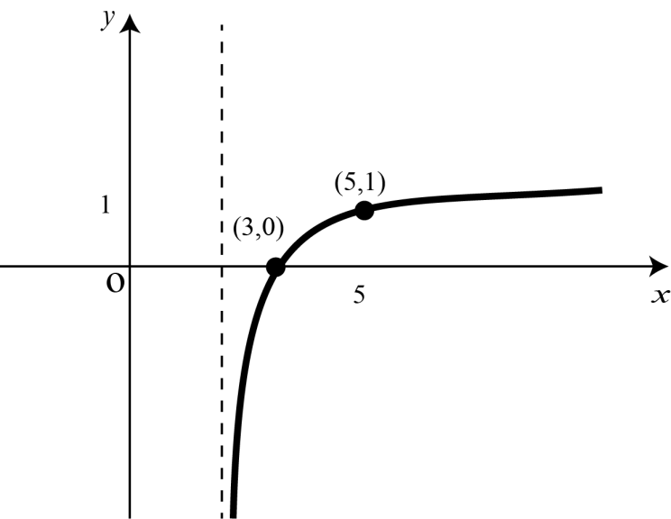

(8, 1)

4

Sketch the graph of y = -f(x) (2)

EF1.3

7 Sketch the graph of for , clearly showing the maximum and minimum values and where it cuts the *x*-axis. (3)

EF1.3

8 The diagram below shows the graph of .

224

8

4









Write down the values of *a*, *b* and *c*. (3)

EF1.3

9 The functions defined on suitable domains, are given by, ,   
  
A third function *h*(*x*) is defined as .

(a) Find an expression for. (2)

EF1.3

(b) Explain why  cannot be a member of the domain of  (#E2.2)

[EF1.3]

10 A function is given by. Find the inverse function  (3)

EF1.3

#### Relationships and Calculus Assessment Standard 1.1

11. (*x* – 2) is a factor of the polynomial *f* (*x*) = *x*3 + 2*x*2 – *kx* + 42.

3 marks

(a) Show that *k* = 29.

(b) Fully factorise *f* (*x*).

3 marks

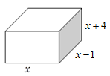

12. This rectangular box shown in the diagram has   
a volume of 12 m3. Its dimensions are in metres.

**(2)**

(a) Show that *x*3 + 3*x*2 – 4*x* – 12 = 0.

**#2.1**

**(5)**

**#2.2**

(b) Hence determine algebraically the dimensions

of the box.

13. The graph of the function f(x) = px2 – x + 3 does not touch

**#2.1**

**(2)**

or cross the x-axis. What are the possible values for p?

17 The diagram shows vectors  and.   
D, E and F have coordinates D(-3, –4, 5), E(2, –6, -3) and F(2, 0, 3).

D

E

F

Find the size of the acute angle EDF. (5)

EF1.4

18 Solve $\sqrt{2}$ sin 2x + 1 = 0 0 < x< 360 (3)

14. ABCDE is a pyramid with rectangular base BCDE.  
  
  
  
  
  
  
  
  
  
  
  
  
  
  
The vectors  are given by:

B

C

D

E

A



Express in component form. (3)

EF1.4

15 Show that the points A (-2, 5, 7), B (2, 3, 10), and C (14,–3, 19) are collinear.

( 4 )

EF1.4

16 The points P, Q and R lie in a straight line, as shown. Q divides PR in the ratio 2:3.

Find the coordinates of Q.

R(12, −11, -12)

Q

P(2, −1, 3)

(3)

EF1.4

**Block 1 Practise 1 Marking Information**

|  |  |  |
| --- | --- | --- |
| Question | **Points of expected response** | Illustrative scheme |
| 1 | •1  interprets gradient  •2  obtains equation | •1  •2  NB can be left in this form |
| Note: No marks should be deducted as a result of an error subsequent to •2 being awarded. | | |
| 2 | •1 interprets perpendicular  •2  substitutes correctly | •1  •2 |
| Note: No marks should be deducted as a result of an error subsequent to •2 being awarded. | | |
| 3 | #2.1 uses correct strategy  •1 finds angle to x-axis | #2.1 evidence of  to find an angle  •1(accept 76°) |
| 4 | •1  uses  #2.2 interprets correct angle and correct explanation | •1  (stated or implied by #2.2)  #2.2 ramp is not safe as  **and** 0.27>0.1 |
| Note: tan 165° also gets •1 as does −tan 165°. | | |
| 5 | •1 correct horizontal translation  •2 correct vertical translation  •3 correctly annotated diagram | •1 *x*-coordinates must be correct  •2 *y*-coordinates must be correct  •3 correct shape and annotation of (0, 1) and (-5, 7) |
| Notes:  Award 2 points of process for correctly drawn and annotated graph of  or  Award 1 point of process for  where *x*-coordinates are consistent,  and  where *y*-coordinates are consistent. | | |
| 6 | •1 correct reflection in x-axis  •2 correctly annotated diagram | •1  •2 correct shape and annotation of (8, -1) |
| 7 | •1 max/min correct  •2 *x* intercepts  •3 correct shape | •1 max  and min  •2  and  •3 correct annotated graph |
| Notes: The *y*-intercept does not require to be annotated.  However, for •3 to be awarded, the *y*-intercept must meet the following criteria:  . | | |
| 8 | •1 finds one unknown  •2 finds second unknown  •3 finds final unknown | •1 *a* = -4  •2 *b* = ½  •3 *c* = 4 |
| 9 (a)  (b) | •1 interpret composite process  •2 completes composition  #2.2 Explain a solution | •1  •2  #2.2 Because 1/0 does not exist.  Or, demonstrates that *x* is not in the domain: |
| 10 | •1 start inverse process  •2 completes transposition  •3 state inverse function | •1  •2  •3 |
| 11 | •1 Strategy to start process of evaluating polynomial, eg direct substitution or synthetic division | •1 *f* (2) = … and begins substitution  or |
|  | •2 Evaluates polynomial and equates to zero | •2 *f* (2) = 58  2*k* = 0  or    and –2*k* + 58 = 0 |
|  | •3 Completes proof | •3 *k* = 29 |
| Notes: Candidates who substitute *k* with 29 at •1 and then evaluate to obtain zero can be awarded full credit — for showing that the converse is true — provided a statement such as ‘so (*x*  2) is a factor when  ’ appears at the end. | | |
| (b) | •1 First linear factor | •1 (*x* – 2)(……….)  or (*x* – 3)(……….)  or (*x* + 7)(……….) |
|  | •2 Extracts quadratic factor | •2 (x2 + 4x – 21) or other consistent with •1 |
|  | •3 Completes factorisation | •3 (x – 2)(x – 3)(x + 7) |
| 12a | •1 Sets up equation | •1 *x*(*x* – 1)(*x* + 4) = 12 |
|  | •2 Multiplies out and = zero | •2 |
| (b) | #2.1 Uses correct strategy | #2.1 Evidence of complete factorisation, ie 3 linear brackets |
|  | •3 Strategy to start solving, eg direct substitution or synthetic division | •3 *f* (*a*) = *b* or synthetic division      To be awarded •3 *a* must be a factor of 12. |
|  | •4 Obtains correct linear factor (or root) | •4    Remainder = 0, (x – 2) is a factor or x = 2 is a root |
|  | •5 Factorises | •5 |
|  | •6 Solves | •6 x = 2, x = -2, and x = -3 |
|  | •7 Shows clearly only one solution | •7 Shows clearly x = -2, and x = -3 have been disregarded |
|  | #2.2 Communicates clearly and relates to the context | #2.2 shows that x = 2 is the only solution, therefore, the box measures  2 metres by 1 metre by 6 metres |
| Notes:•4 is only available for obtaining (*x* – 2) as a factor or *x* = 2 as a root.  #2.1 for evidence of an attempt at solving can only be given if •4 has been awarded. |  |  |
| 13 | #2.1 Knows to use the discriminant and substitutes correctly | #2.1 b2 - 4ac < 0  (-1)2- 4 x p x 3 < 0 |
|  | •1 completes substitution process and starts to solve the inequality | •1 1 – 12p < 0 |
|  | •2 solves the inequality | •2 1/12 < p |
| 14 | •1 recognise a pathway for  •2 identifyvector  •3 complete calculation for | •1  •2  •3 |
| Note: Do not award •3 for (17, -3, 9). | | |
| 15 | •1 interpret vector  •2 interpret multiple of vector  •3 complete proof | •1 eg    •2eg    •3  hence vectors are parallel, but B is a common point so A, B and C are collinear. |
| 16 | •1 find vector components  •2 uses correct ratio  •3 processes vectors and finds coordinates of S | •1    •2    •3  NB If candidates use the Section formula:  •1 begins substitution  •2 completes substitution  •3 as •3 above |
| Note: •3 is only available if expressed as a coordinate. | | |
| 17 | •1 find vector components  •2 use scalar product  •3 process scalar product  •4 process  and  ie calculate magnitudes  •5 find angle | •1    •2    •3    •4  and  •5 angle = 1.04 radians or 59.3° |
| 18 | * Rearrange equation * Start to solve * Find all solutions | $\sin{2x=\frac{1}{\sqrt{2}}}$* 2x = 225, 315, 585, 675 * x = 112.5, 157.5, 292.5, 337.5 |