POUNDS AND PENCE

There are 100 pennies in a pound.
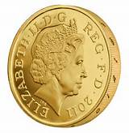
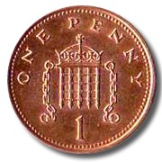
100 = 1

We can write 100 pennies in 2 different ways:

100p or £1

When we write down the cost of something we can write it in 2 ways. We can write it as pence or as pounds. So,

50p can be written as £0.50

15p can be written as £0.15

99p can be written as £0.99

76p can be written as £0.76
When we write £0.65 we are saying that we have 0 pounds and 65p.

Can you write the amounts below in a different way?

£0.42 |  | £0.22
54p |  | £0.73
80p |  | 49p
£0.69 |  | 95p
32p |  | £0.01
10p |  | 8p

When there is a number other than 0 after the pound sign this tells us how many pounds there are. So

£1.20 tells us we have £1 and 20p

we could write £1.20 as 120p but it’s better to write it with the £ sign.

Can you write the following amounts using a £ sign?

150p | £1.50 | 125p
191p |  | 137p
139p |  | 174p
181p |  | 259p
261p |  | 299p
537p |  | 463p
693p |  | 842p
306p |  | 508p
388p |  | 719p
848p |  | 572p
307p |  | 666p
753p |  | 496p
909p |  | 600p
Now can you write these amounts using pence.

£1.87 |  | £1.43
£1.22 |  | £1.94
£1.88 |  | £1.51
£1.03 |  | £1.35
£1.66 |  | £1.70
£2.59 |  | £2.31
£3.62 |  | £3.86
£4.74 |  | £6.49
£5.00 |  | £6.20
£0.45 |  | £4.50
£4.05 |  | £7.77
£7.07 |  | £0.77

OUR SCHOOL SECONDARY TUCK SHOP

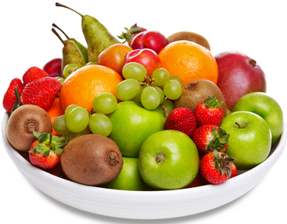 | 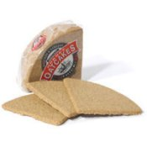 |  | 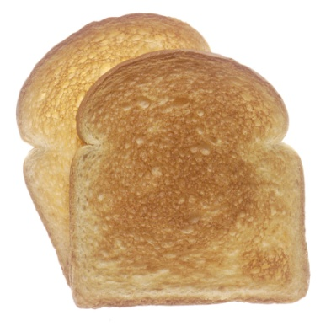 | 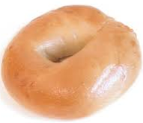
Fresh Fruit 40 p | 1 Oatcake and Spread – 20p | Fruit Muffin – 50p | Toast and Spread/Jam – 30p | Bagel and Jam/Spread – 50p
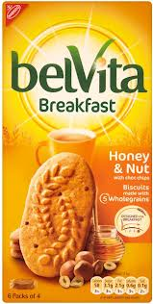 |  | 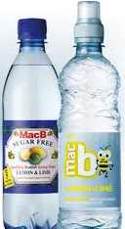 |  | 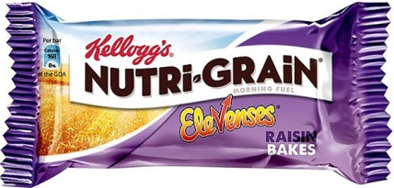
Breakfast Biscuits – 50p a pack | 2 Breadsticks – 10p | Flavoured Water – 50p | 3 Crackers and Spread – 30p | Cereal Bar – 40p
How much does it cost to buy? Draw the coins you would use to pay with. Then decide whether you can afford to buy it with the money you have.

ITEMS | COST | COINS USED TO PAY | MONEY AVAILABLE | CAN BUY?  CAN’T BUY?
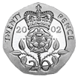
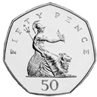
 |  |  | 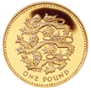
 |  |  | 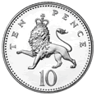

Now, use a calculator to work out how much it costs to buy 2, 3, or 4 of each item.

 | 1 | 2 | 3 | 4 | 5

Count the money below, write down how much it is then using the table on the last page choose the thing that is nearest to that amount (but not over it).

